Secretaria Ref.: | Date: 23/10/2003 | File Name: ICD_UFSC.doc

UFSC CPL/CBEMG/FLUXRAD INTERFACE CONTROL DOCument

Prepared by: | Heitor Victor Ribeiro Camargo  Saulo Güths  Carlos Eduardo Paghi  Eduardo Ludgero  Luís Felipe Batiani Possamai | Date et Visa
Accepted by: |  | Date et Visa
Approved by: | Edson Bazzo - UFSC  J. C. Passos - UFSC  Saulo Guths - LMPT-UFSC  Project Management Team  HIMILCON DE CASTRO CARVALHO-INPE | Date et Visa

Configuration controlled Document | YES | By: | Since:

DOCUMENT STATUS

Page | All
Issue | 00
Review | 00

    FBM |  |  | Document No. : | FBM-IC-UE-07-7142-INP
 |  |  | Page | 2
 |  |  | IDENT: | ICD-FBM-CP-07-740.000.00
INTERFACE CONTROL DOC. |  |  | EDITION N°: | 00 / Rev : 00
 |  |  | DATE: | 23/10/2003
SUBSYSTEM : | UFSC CPL/CBEMG/FLUXRAD |  | EQUIPMENT : | UFSC CPL/CBEMG/FLUXRAD
FORM TYPE : | MECHANICAL CHARACTERISTICS
TOTAL NUMBER: | 1 | IN OPERATION: | 1 | IN REDUNDANCY: | 0

MASS PROPERTIES:

DIMENSIONS (mm):

L=421.0 B =320.0 H =190.0

UNIT MASS (Kg): 6,5
TOTAL MASS (Kg): 6,5

CG LOCATION (mm):

l medio = -0.563 +/- b medio = -33.335 +/- h medio = 87.184 +/-

INERTIAS THROUGH CG (Kg m):

Ill = Ibb = Ihh =

MOUNTING POINTS (BOX UFSC) :

QTY = 6
∅ (mm) = 5,2

BASE PLATE

MATERIAL (SYMBOL) = aluminium

CONTACT AREA (mm2) = 127.42

CONTACT SURFACE CONDITION: see sketch pg 6

REMARKS : 8/14/00

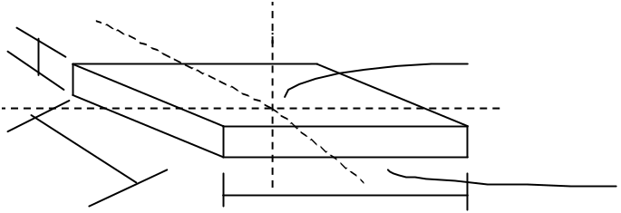
H
B
L
Mounting face
CG
lh
I
lb

l medio, b medio , h medio e h are related to the equipment reference hole. Irregular shapes shall be specified on separate sheet.

FBM |  |  | Document No. : | FBM-IC-UE-07-7142-INP
 |  |  | Page | 3
 |  |  | IDENT: | ICD-FBM-CP-07-740.000.00
INTERFACE CONTROL DOC. |  |  | EDITION N°: | 00 / Rev : 00
 |  |  | DATE: | 23/10/2003
SUBSYSTEM : | UFSC CPL/CBEMG/FLUXRAD |  | EQUIPMENT : | UFSC CPL/CBEMG/FLUXRAD
FORM TYPE : | EQUIPMENT SKETCH
TOTAL NUMBER: |  | IN OPERATION: |  | IN REDUNDANCY:

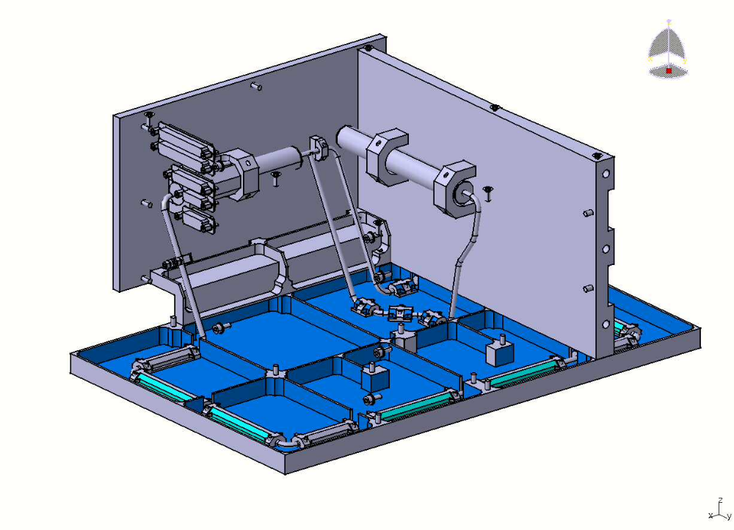

FBM |  |  | Document No. : | FBM-IC-UE-07-7142-INP
 |  |  | Page | 4
 |  |  | IDENT: | ICD-FBM-CP-07-740.000.00
LAYOUT INFORMATION |  |  | EDITION N°: | 00 / Rev : 00
 |  |  | DATE: | 23/10/2003
SUBSYSTEM : | UFSC CPL/CBEMG/FLUXRAD |  | EQUIPMENT : | UFSC CPL/CBEMG/FLUXRAD
FORM TYPE : | EQUIPMENT POSITIONING REQUIREMENTS
TOTAL NUMBER: |  | IN OPERATION: |  | IN REDUNDANCY:

REQUIRES EXTERNAL ACCESS: NO

EXTERNAL SURFACE (mm): Absorber plate (150 x 270): +x
Radiator plate (270 x 421): -y

POINTING REQUIREMENTS: Sun point attitude: +x

EQUIPMENT TO BE CONECTED:

to the PDU and BPC for electrical power
to the BPC(I/O unit) for direct temperature and pressure measurement
to the FLUXRAD back experiment

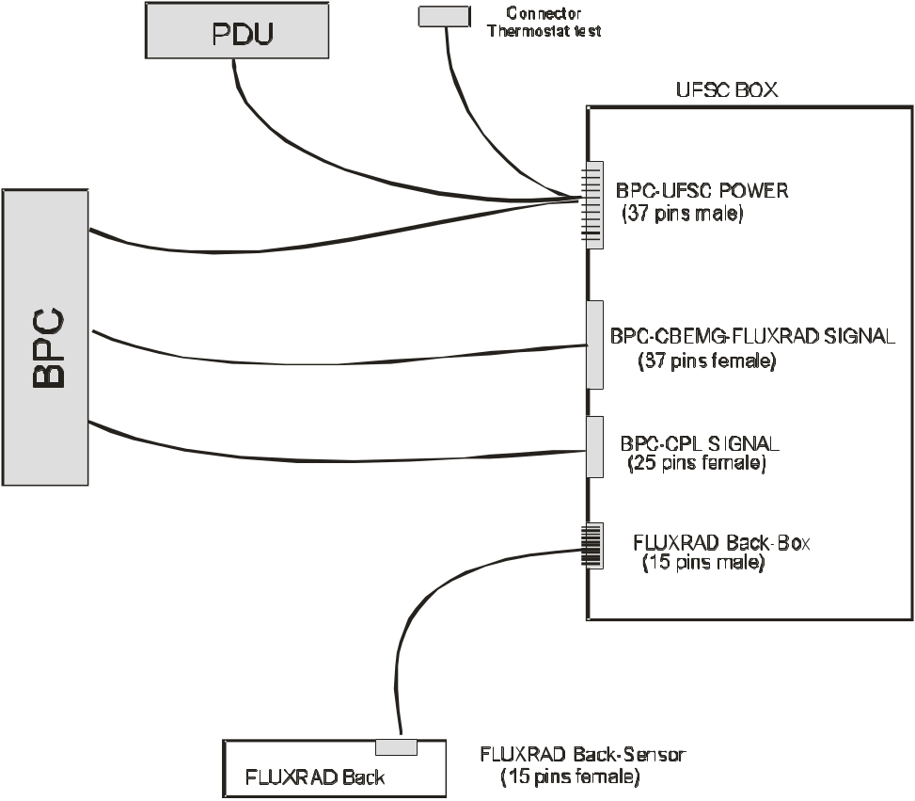

FBM |  |  | Document No. : | FBM-IC-UE-07-7142-INP
 |  |  | Page | 5
 |  |  | IDENT: | ICD-FBM-CP-07-740.000.00
INTERFACE CONTROL DOC. |  |  | EDITION N°: | 00 / Rev : 00
 |  |  | DATE: | 23/10/2003
SUBSYSTEM : | UFSC CPL/CBEMG/FLUXRAD |  | EQUIPMENT : | UFSC CPL/CBEMG/FLUXRAD
FORM TYPE : | THERMAL CHARACTERISTICS
TOTAL NUMBER: |  | IN OPERATION: |  | IN REDUNDANCY:

NUMBER OF UNITS = 1

SIDE AND TOP FACES: not applicable*

MATERIAL =

SURFACE FINISH =

ε (EMIS) =

α (ABS) =

HEAT CAPACITY (J / K) = not applicable*

EFECTIVE THERMAL CONDUCTANCE BETWEEN UFSC BOX AND THE SATELLITE PANEL (W/ K) =0.02

OPERATING TEMPERATURE LIMITS (deg. C) = from -60 to 100

START-UP TEMPERATURE (deg. C) = –60** to –5***

HEAT DISSIPATION (W) = SEE BELLOW

ON: CPL - 15W CBEMG - 15W****

STAND-BY: CPL - 5W CBEMG - 0W

REMARKS :

* The experiment is thermally isolated from the satellite
** Temperature reached while CPL is not running or in fail
*** Temperature reached while CPL is running
**** CPL operates separately from CBEMG

UFSC box is connected to the satellite by 6 M5 titanium screws, thermally isolated with 12 fiberglass washers.
Effective thermal conductance between absorber plate and UFSC box is equal to 0.03 W/K by 10 stainless steel screws thermally isolated with 7 fiberglass washers and 3 aluminnun washers.

Effective thermal conductance between radiator plate and UFSC box is equal to 0.4 W/K

FBM |  |  | Document No. : | FBM-IC-UE-07-7142-INP
 |  |  | Page | 6
 |  |  | IDENT: | ICD-FBM-CP-07-740.000.00
INTERFACE CONTROL DOC. |  |  | EDITION N°: | 00 / Rev : 00
 |  |  | DATE: | 23/10/2003
SUBSYSTEM : | UFSC CPL/CBEMG/FLUXRAD |  | EQUIPMENT : | UFSC CPL/CBEMG/FLUXRAD
FORM TYPE : | THERMAL SKETCH
TOTAL NUMBER: |  | IN OPERATION: |  | IN REDUNDANCY:

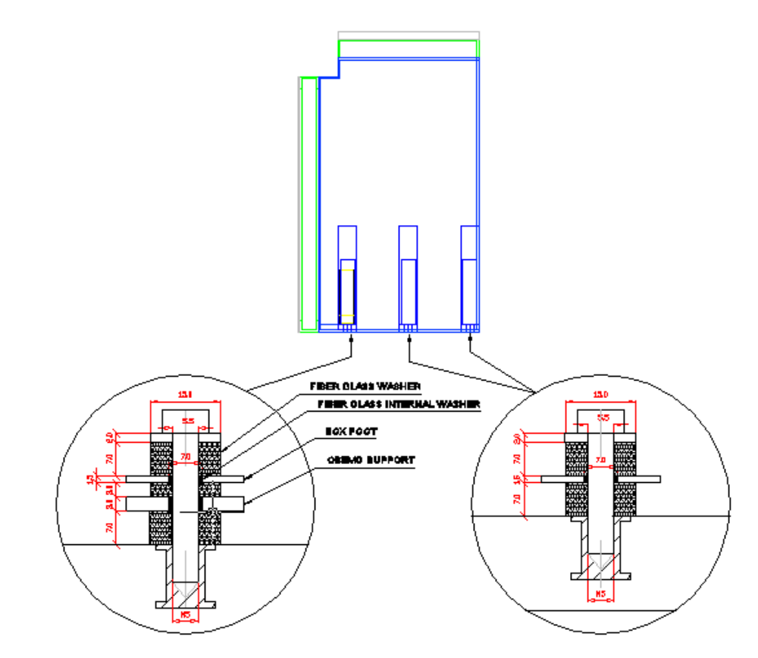

FBM |  |  | Document No. : | FBM-IC-UE-07-7142-INP
 |  |  | Page | 7
 |  |  | IDENT: | ICD-FBM-CP-07-740.000.00
INTERFACE CONTROL DOC. |  |  | EDITION N°: | 00 / Rev : 00
 |  |  | DATE: | 23/10/2003
SUBSYSTEM : | UFSC CPL/CBEMG/FLUXRAD |  | EQUIPMENT : | UFSC CPL/CBEMG/FLUXRAD
FORM TYPE : | ELECTRICAL POWER
TOTAL NUMBER: | 0 | IN OPERATION: | 0 | IN REDUNDANCY: | 0

MODES (ON, STAND BY, OTHER) | SUPPLY VOLTAGE (V) | POWER (W) | VOLTAGE REGULATION (± %) | RIPPLE Vp-p
POWCPL1 (CPL Surviving)* | 22-37 V | 5 | no effect | 22-37 V
POWCPL2 (CPL Recovery)** | 22-37 V | 5 | no effect | 22-37 V
POWCPL3 (CPL On) | 22-37 V | 15 | no effect | 22-37 V
POWPDU *** | 22-37 V | 5 | no effect | 22-37 V
CBEMG On 1 | 22-37 V | 16 | no effect | 22-37 V
CBEMG On 2 | 22-37 V | 16 | no effect | 22-37 V
CBEMG On 3 | 22-37 V | 16 | no effect | 22-37 V
CBEMG On 4 | 22-37 V | 16 | no effect | 22-37 V
FLUXRAD | 22-37 V | 4*** | no effect | 22-37 V

REMARKS:
* Power input required in the reservoir to support the CPL during normal operation.
** Power input required in the reservoir in case of startup failure.
*** Power input coming from the PDU to avoid freezing when both CPL and CBEMG are not operating; It's an on/off electrical resistance controlled by a thermostat.
**** Calculated for maximum levels of current and voltage.

POWCPL1 and POWPDU will never operate simultaneously.

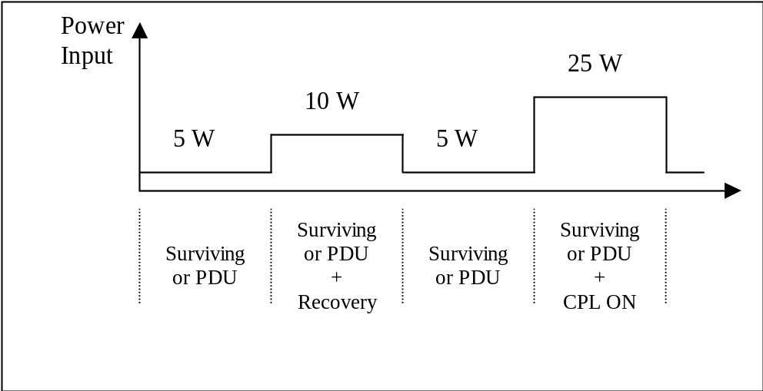
20W

The power required for the electronic system is not included in the picture above

FBM |  |  | Document No. : | FBM-IC-UE-07-7142-INP
 |  |  | Page | 8
 |  |  | IDENT: | ICD-FBM-CP-07-740.000.00
INTERFACE CONTROL DOC. |  |  | EDITION N°: | 00 / Rev : 00
 |  |  | DATE: | 23/10/2003
SUBSYSTEM : | UFSC CPL/CBEMG/FLUXRAD |  | EQUIPMENT : | UFSC CPL/CBEMG/FLUXRAD
FORM TYPE : | LIST OF CONNECTORS
TOTAL NUMBER: |  | IN OPERATION: |  | IN REDUNDANCY:

REFERENCE OF CONNECTOR | CONNECTOR DESCRIPTION | MALE/FEMALE | CONNECTOR
1 | BPC-CPL SIGNAL | F | D CONNECTOR 25 PINS
2 | BPC-CBEMG-FLUXRAD SIGNAL | F | D CONNECTOR 37 PINS
3 | BPC-UFSC POWER | M | D CONNECTOR 37 PINS
4 | FLUXRAD Back | M | D CONNECTOR 15 PINS

Connector Cannon
D Subminiature
Space/High Reliability
Straight PC Tail

Codes:

1 - DBMY25SOL3NMK52
2 - DCMY37SOL3NMK52
3 - DCMY37POL3NMK52
4 - DAMY15POL3NMK52

FBM |  |  | Document No. : | FBM-IC-UE-07-7142-INP
 |  |  | Page | 9
 |  |  | IDENT: | ICD-FBM-CP-07-740.000.00
INTERFACE CONTROL DOC. |  |  | EDITION N°: | 00 / Rev : 00
 |  |  | DATE: | 23/10/2003
SUBSYSTEM : | UFSC CPL/CBEMG/FLUXRAD |  | EQUIPMENT : | UFSC CPL/CBEMG/FLUXRAD
FORM TYPE : | PIN ASSIGNMENTS IN CONNECTOR
TOTAL NUMBER: |  | IN OPERATION: |  | IN REDUNDANCY:

CONNECTOR: DESCRIPTION BPC - CPL SIGNAL
PIN | NAME | FUNCTION | VOLT [V] | CURRENT Max. [mA] | POL
1 | CPLAN1 | Thermistor 1- Liquid temperature at outlet condenser | 5 | 0.1 | (+)
2 | CPLAN2 | Thermistor 2- Liquid temperature | 5 | 0.1 | (+)
3 | CPLAN3 | Thermistor 3- Liquid temperature at inlet capillary pump | 5 | 0.1 | (+)
4 | CPLAN4 | Thermistor 4- Capillary pump temperature inlet | 5 | 0.1 | (+)
5 | CPLAN5 | Thermistor 5- Capillary pump temperature outlet | 5 | 0.1 | (+)
6 | CPLAN6 | Thermistor 6- Vapor temperature at outlet capillary pump | 5 | 0.1 | (+)
7 | CPLAN7 | Thermistor 7- Vapor temperature at inlet condenser | 5 | 0.1 | (+)
8 | CPLAN8 | Thermistor 8- Condenser temperature | 5 | 0.1 | (+)
9 | CPLAN9 | Thermistor 9- Condenser temperature | 5 | 0.1 | (+)
10 | CPLAN10 | Thermistor 10- Condenser temperature | 5 | 0.1 | (+)
11 | CPLAN11 | Thermistor 11- Condenser temperature | 5 | 0.1 | (+)
12 | CPLAN12 | Thermistor 12- Liquid temperature at inlet reservoir | 5 | 0.1 | (+)
13 | CPLAN13 | Thermistor 13- Liquid temperature at outlet reservoir | 5 | 0.1 | (+)
14 | CPLAN14 | Thermistor 14- Reservoir temperature | 5 | 0.1 | (+)
15 | CPLAN15 | Thermistor 15- Radiator temperature | 5 | 0.1 | (+)
16 | CPLAN16 | Thermistor 16- Radiator temperature | 5 | 0.1 | (+)
17 | CPLAN17 | Thermistor 17- Absorber temperature | 5 | 0.1 | (+)
18 | CPLAN18 | Thermistor 18- Absorber temperature | 5 | 0.1 | (+)
19 | CPLAN19 | Thermistor 19- Reservoir temperature | 5 | 0.1 | (+)
20 | CPLAN20 | Thermistor 20- Liquid temperature at the middle of reservoir line | 5 | 0.1 | (+)
21 | -----
22 | MECGND | Mechanical ground | 0 | 0
23 | CPLANRTN | CPL return | 0 | 0.7 | (-)
24 | CPLANRTN | CPL return | 0 | 0.7 | (-)
25 | CPLANRTN | CPL return | 0 | 0.7 | (-)

FBM |  |  | Document No. : | FBM-IC-UE-07-7142-INP
 |  |  | Page | 10
 |  |  | IDENT: | ICD-FBM-CP-07-740.000.00
INTERFACE CONTROL DOC. |  |  | EDITION N°: | 00 / Rev : 00
 |  |  | DATE: | 23/10/2003
SUBSYSTEM : | UFSC CPL/CBEMG/FLUXRAD |  | EQUIPMENT : | UFSC CPL/CBEMG/FLUXRAD
FORM TYPE : | PIN ASSIGNMENTS IN CONNECTOR
TOTAL NUMBER: |  | IN OPERATION: |  | IN REDUNDANCY:

CONNECTOR DESCRIPTION: BPC-CBEMG –FLUXRAD SIGNAL
PIN | NAME | FUNCTION | VOLT [V] | CURRENT [mA] | POL
1 | CBEMGANRTN | CBEMG return | 0 | 0.8 | (-)
2 | CBEMGAN1 | Thermocouple 1 | 5 | 0.1 | (+)
3 | CBEMGAN2 | Thermocouple 2 | 5 | 0.1 | (+)
4 | CBEMGAN3 | Thermocouple 3 | 5 | 0.1 | (+)
5 | CBEMGAN4 | Thermocouple 4 | 5 | 0.1 | (+)
6 | CBEMGAN5 | Thermocouple 5 | 5 | 0.1 | (+)
7 | CBEMGAN6 | Thermocouple 6 | 5 | 0.1 | (+)
8 | CBEMGAN7 | Thermocouple 7 | 5 | 0.1 | (+)
9 | CBEMGAN8 | Thermocouple 8 | 5 | 0.1 | (+)
10 | FLUXAN1 | Black Flux - Back | 5 | 0.1 | (+)
11 | FLUXAN2 | White Flux - Back | 5 | 0.1 | (+)
12 | FLUXAN3 | Polished Flux – Back | 5 | 0.1 | (+)
13 | FLUXAN4 | Black Flux - Front | 5 | 0.1 | (+)
14 | FLUXAN5 | White Flux - Front | 5 | 0.1 | (+)
15 | FLUXAN6 | Polished Flux – Front | 5 | 0.1 | (+)
16 | FLUXAN7 | Temp 1 - Back | 5 | 0.1 | (+)
17 | FLUXAN8 | Temp 2 - Back | 5 | 0.1 | (+)
18 | FLUXANRTN | FLUXRAD return | 0 | 0.7 | (-)
19 | MECGND | Mechanical ground | 0 | 0
20 | CBENGANRTN | CBEMG return | 0 | 0.8 | (-)
21 | CBEMGAN9 | Temp. Section 01 | 5 | 0.1 | (+)
22 | CBEMGAN10 | Skin heater voltage 1 | 5 | 0.1 | (+)
23 | CBEMGAN11 | Skin heater voltage 2 | 5 | 0.1 | (+)
24 | CBEMGAN12 | Skin heater voltage 3 | 5 | 0.1 | (+)
25 | CBEMGAN13 | Skin heater voltage 4 | 5 | 0.1 | (+)
26 | CBEMGAN14 | Temperature Reference | 5 | 0.1 | (+)
27 | CBEMGAN15 | Voffset | 5 | 0.1 | (+)
28 | CBEMGAN16 | Thermistors supply | 5 | 0.1 | (+)
29 | FLUXAN9 | Temp 3 - Back | 5 | 0.1 | (+)
30 | FLUXAN10 | Temp 4 - Back | 5 | 0.1 | (+)
31 | FLUXAN11 | Temp 1 - Front | 5 | 0.1 | (+)
32 | FLUXAN12 | Temp 2 - Front | 5 | 0.1 | (+)
33 | FLUXAN13 | Temp 3 - Front | 5 | 0.1 | (+)
34 | FLUXAN14 | Temp 4 - Front | 5 | 0.1 | (+)
35 | FLUXAN15 | Voffset | 5 | 0.1 | (+)
36 | FLUXAN16 | Thermistors supply | 5 | 0.1 | (+)
37 | FLUXANRTN | FLUXRAD return | 0 | 0.7 | (-)

FBM |  |  | Document No. : | FBM-IC-UE-07-7142-INP
 |  |  | Page | 11
 |  |  | IDENT: | ICD-FBM-CP-07-740.000.00
INTERFACE CONTROL DOC. |  |  | EDITION N°: | 00 / Rev : 00
 |  |  | DATE: | 23/10/2003
SUBSYSTEM : | UFSC CPL/CBEMG/FLUXRAD |  | EQUIPMENT : | UFSC CPL/CBEMG/FLUXRAD
FORM TYPE : | PIN ASSIGNMENTS IN CONNECTOR
TOTAL NUMBER: |  | IN OPERATION: |  | IN REDUNDANCY:

CONNECTOR DESCRIPTION: FLUXRAD BACK
PIN | NAME | FUNCTION | VOLT [V] | CURRENT [mA] | POL
1 | FLUXSIG1 BACK | Black Flux | 0.1 | 0.1 | (+)
2 | FLUXSIG2 BACK | White Flux | 0.1 | 0.1 | (+)
3 | FLUXSIG3 BACK | Polished Flux | 0.1 | 0.1 | (+)
4 | FLUXSIG4 BACK | Temp 1 | 5 | 0.5 | (+)
5 | FLUXSIG5 BACK | Temp 2 | 5 | 0.5 | (+)
6 | FLUXSIG6 BACK | Temp 3 | 5 | 0.5 | (+)
7 | FLUXSIG7 BACK | Temp 4 | 5 | 0.5 | (+)
8 | ------
9 | POWSENFLUXRAD | Thermistors supply | 5 | 1 | (+)
10 | POWSENFLUXRAD | Thermistors supply | 5 | 1 | (+)
11 | FLUXSIGRTN | Return | 0 | 0.1 | (-)
12 | FLUXSIGRTN | Return | 0 | 0.1 | (-)
13 | MECGND | Return | 0
14 | MECGND | Mechanical ground | 0
15 | MECGND | Mechanical ground | 0

FBM |  |  | Document No. : | FBM-IC-UE-07-7142-INP
 |  |  | Page | 12
 |  |  | IDENT: | ICD-FBM-CP-07-740.000.00
INTERFACE CONTROL DOC. |  |  | EDITION N°: | 00 / Rev : 00
 |  |  | DATE: | 23/10/2003
SUBSYSTEM : | UFSC CPL/CBEMG/FLUXRAD |  | EQUIPMENT : | UFSC CPL/CBEMG/FLUXRAD
FORM TYPE : | PIN ASSIGNMENTS IN CONNECTOR
TOTAL NUMBER: |  | IN OPERATION: |  | IN REDUNDANCY:

CONNECTOR DESCRIPTION: BPC-UFSC POWER
PIN | NAME | FUNCTION | VOLT [V] | CURRENT [mA] | POL
1 | POWCPL1 | Surviving power | 37 | 115 | (+)
2 | POWCPL2 | Recovery power | 37 | 115 | (+)
3 | POWCPL3 | On power | 37 | 450 | (+)
4 | POWPDU * | PDU power | 37 | 115 | (+)
5 | LCL3RTN | Surviving, recovery and on return | 0 | 460
6 | POWRTNPDU * | PDU return | 0 | 115
7 | POWCBEMG1 | Skin heater voltage 1 | 37 | 500 | (+)
8 | POWCBEMG2 | Skin heater voltage 2 | 37 | 500 | (+)
9 | POWCBEMG3 | Skin heater voltage 3 | 37 | 500 | (+)
10 | POWCBEMG4 | Skin heater voltage 4 | 37 | 500 | (+)
11 | POWRTNCBEMG | Skin heaters return | 0 | 500
12 | POWFLUXRAD | Electronics power | 37 | 20 | (+)
13 | LCL7RTN | Electronics return | 0 | 20
14 | LCL5 * | CBEMG converter power | 37 | 500 | (+)
15 | LCL5RTN * | CBEMG converter return | 0 | 500
16 | PLUS15V | CBEMG current supply power | 15 | 335 | (+)
17 | PLUS15V | CBEMG current supply power | 15 | 335 | (+)
18 | THERMOST1 | Thermostat 1 test point | 5 | 335 | (+)
19 | MECGND | Mechanical ground | 0 | 0
20 | POWCPL1 | Surviving power | 37 | 115 | (+)
21 | POWCPL2 | Recovery power | 37 | 115 | (+)
22 | POWCPL3 | On power | 37 | 450 | (+)
23 | THERMOSTCOM | Thermostat common test point | 37 | 115 | (+)
24 | LCL3RTN | Surviving, recovery and on return | 0 | 900
25 | THERMOST2 | Thermostat 2 test point | 0 | 115
26 | POWCBEMG1 | Skin heater voltage 1 | 37 | 500 | (+)
27 | POWCBEMG2 | Skin heater voltage 2 | 37 | 500 | (+)
28 | POWCBEMG3 | Skin heater voltage 3 | 37 | 500 | (+)
29 | POWCBEMG4 | Skin heater voltage 4 | 37 | 500 | (+)
30 | POWRTNCBEMG | Skin heaters return | 0 | 500
31 | POWFLUXRAD | Electronics power | 37 | 20 | (+)
32 | LCL7RTN | Electronics return | 0 | 20
33 | LCL5 * | CBEMG converter power | 37 | 500 | (+)
34 | LCL5RTN * | CBEMG converter return | 0 | 500
35 | PLUS15VRTN | CBEMG current supply return | 0 | 335
36 | PLUS15VRTN | CBEMG current supply return | 0 | 335
37 | PLUS15VRTN | CBEMG current supply return | 0 | 335

* connected to PDU

FBM |  |  | Document No. : | FBM-IC-UE-07-7142-INP
 |  |  | Page | 13
 |  |  | IDENT: | ICD-FBM-CP-07-740.000.00
INTERFACE CONTROL DOC. |  |  | EDITION N°: | 00 / Rev : 00
 |  |  | DATE: | 23/10/2003
SUBSYSTEM : | UFSC CPL/CBEMG/FLUXRAD |  | EQUIPMENT : | UFSC CPL/CBEMG/FLUXRAD
FORM TYPE : | THERMAL SKETCH
TOTAL NUMBER: |  | IN OPERATION: |  | IN REDUNDANCY:

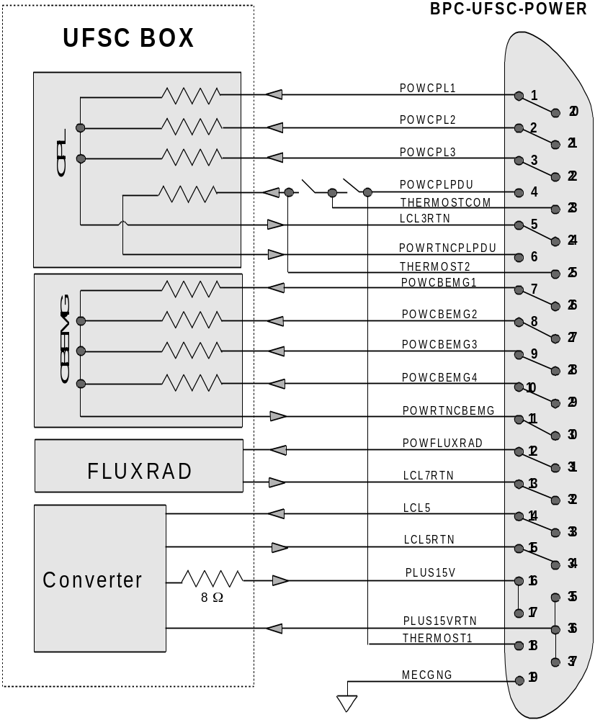

FBM |  |  | Document No. : | FBM-IC-UE-07-7142-INP
 |  |  | Page | 14
 |  |  | IDENT: | ICD-FBM-CP-07-740.000.00
INTERFACE CONTROL DOC. |  |  | EDITION N°: | 00 / Rev : 00
 |  |  | DATE: | 23/10/2003
SUBSYSTEM : | UFSC CPL/CBEMG/FLUXRAD |  | EQUIPMENT : | UFSC CPL/CBEMG/FLUXRAD
FORM TYPE : | TELECOMMAND LIST
TOTAL NUMBER: |  | IN OPERATION: |  | IN REDUNDANCY:

ID DESCRIPRION | TYPE | PARAMETER REMARKS
ID DESCRIPRION | TYPE | MEANING
CPL
TC (TC1 ,TC2, TC3,TC4,TC5,TC6,TC7,TC8,TC9) | D |  | 1
TC1 – TOP |  |  | 2
TC2 – DELTAT |  |  | 3
TC3 – change from CPLAN4 to CPLAN5
TC4 – change from CPLAN13 to CPLAN14
TC5 – DELTATP |  |  | 4
TC6 – change from CPLAN8 to CPLAN9
TC7 – TS |  |  | 5
TC8 – change from CPLAN14 to CPLAN5
TC9 – DELTATR |  |  | 6
CBEMG
TC8 - CBEMG 1 On/Off | D |  | 1
TC9 - CBEMG 2 On/Off | D |  | 1
TC10 - CBEMG 3 On/Off | D |  | 1
TC11 - CBEMG 4 On/Off | D |  | 1
TC12 - CBEMG Type | D |  | 1

Remarks:
1 – The telecommands acts on the softwawre;
2 – TOP = Reservoir Temperature;
3 – DELTAT = Temperature Difference between Capillary Pump and Vapor line;
4 – DELTATP = Temperature Difference between Reservoir and Capillary Pump;
5 – TS = Maximun Temperature;
6 – DELTATR = Temperature Difference between Capillary Pump and Reservoir;

FBM |  |  | Document No. : | FBM-IC-UE-07-7142-INP
 |  |  | Page | 15
 |  |  | IDENT: | ICD-FBM-CP-07-740.000.00
INTERFACE CONTROL DOC. |  |  | EDITION N°: | 00 / Rev : 00
 |  |  | DATE: | 23/10/2003
SUBSYSTEM : | UFSC CPL/CBEMG/FLUXRAD |  | EQUIPMENT : | UFSC CPL/CBEMG/FLUXRAD
FORM TYPE : | TELEMETRY LIST
TOTAL NUMBER: |  | IN OPERATION: |  | IN REDUNDANCY:

ID DESCRIPTION | TYPE | CONN. | UNIT | ACCURACY
CPL
CPLAN1 - Liquid temperature at outlet condenser
CPLAN2 - Liquid temperature
CPLAN3 - Liquid temperature at inlet capillary pump
CPLAN4 - Capillary pump temperature inlet
CPLAN5 - Capillary pump temperature outlet
CPLAN6 - Vapor temperature at outlet capillary pump
CPLAN7 - Vapor temperature at inlet condenser
CPLAN8 - Condenser temperature
CPLAN9 - Condenser temperature
CPLAN10 - Condenser temperature
CPLAN11 - Condenser temperature
CPLAN12 - Liquid temperature at inlet reservoir
CPLAN13 - Liquid temperature at outlet reservoir
CPLAN14 - Reservoir temperature
CPLAN15 - Radiator temperature
CPLAN16 - Radiator temperature
CPLAN17 - Absorber temperature
CPLAN18 - Absorber temperature
CPLAN19 - Reservoir temperature
CPLAN20 - Liquid temperature at the middle of reservoir line
FLUXRAD
FLUXAN1 - Black Heat fluxmeter - Back
FLUXAN2 - White Heat fluxmeter - Back
FLUXAN3 - Polished Heat fluxmeter - Back
FLUXAN4 - Black Heat fluxmeter - Front
FLUXAN5 - White Heat fluxmeter - Front
FLUXAN6 - Polished Heat fluxmeter - Front
FLUXAN7 - Radiometer 1 - Back
FLUXAN8 - Radiometer 2 - Back
FLUXAN9 - Radiometer 3 - Back
FLUXAN10 - Radiometer 4 - Back
FLUXAN11 - Radiometer 1 - Front
FLUXAN12 - Radiometer 2 - Front
FLUXAN13 - Radiometer 3 - Front
FLUXAN14 - Radiometer 4 - Front
FLUXAN15 – Offset voltage
FLUXAN16 – Supply thermistors voltage

Obs.:
Sensor readings: CPL: Each 3 seconds
FLUXRAD: Each 3 seconds
Pack all data before sending to ground station

FBM |  |  | Document No. : | FBM-IC-UE-07-7142-INP
 |  |  | Page | 16
 |  |  | IDENT: | ICD-FBM-CP-07-740.000.00
INTERFACE CONTROL DOC. |  |  | EDITION N°: | 00 / Rev : 00
 |  |  | DATE: | 23/10/2003
SUBSYSTEM : | UFSC CPL/CBEMG/FLUXRAD |  | EQUIPMENT : | UFSC CPL/CBEMG/FLUXRAD
FORM TYPE : | TELEMETRY LIST
TOTAL NUMBER: |  | IN OPERATION: |  | IN REDUNDANCY:

ID DESCRIPTION | TYPE | CONN. | UNIT | ACCURACY
CBEMG
CBEMGAN1 Thermocouple 1
CBEMGAN2 Thermocouple 2
CBEMGAN3 Thermocouple 3
CBEMGAN4 Thermocouple 4
CBEMGAN5 Thermocouple 5
CBEMGAN6 Thermocouple 6
CBEMGAN7 Thermocouple 7
CBEMGAN8 Thermocouple 8
CBEMGAN9 Fluxmeter
CBEMGAN10 Skin heater voltage 1
CBEMGAN11 Skin heater voltage 2
CBEMGAN12 Skin heater voltage 3
CBEMGAN13 Skin heater voltage 4
CBEMGAN14 Temperature reference thermistor
CBEMGAN15 Offset voltage
CBEMGAN16 Supply thermistor voltage

Obs.:
Sensor readings: Each 75 milisseconds
Pack all data before sending to ground station

FBM |  |  | Document No. : | FBM-IC-UE-07-7142-INP
 |  |  | Page | 17
 |  |  | IDENT: | ICD-FBM-CP-07-740.000.00
INTERFACE CONTROL DOC. |  |  | EDITION N°: | 00 / Rev : 00
 |  |  | DATE: | 23/10/2003
SUBSYSTEM : | UFSC CPL/CBEMG/FLUXRAD |  | EQUIPMENT : | UFSC CPL/CBEMG/FLUXRAD
FORM TYPE : | CPL CONTROL PROCEDURE
TOTAL NUMBER: |  | IN OPERATION: |  | IN REDUNDANCY:

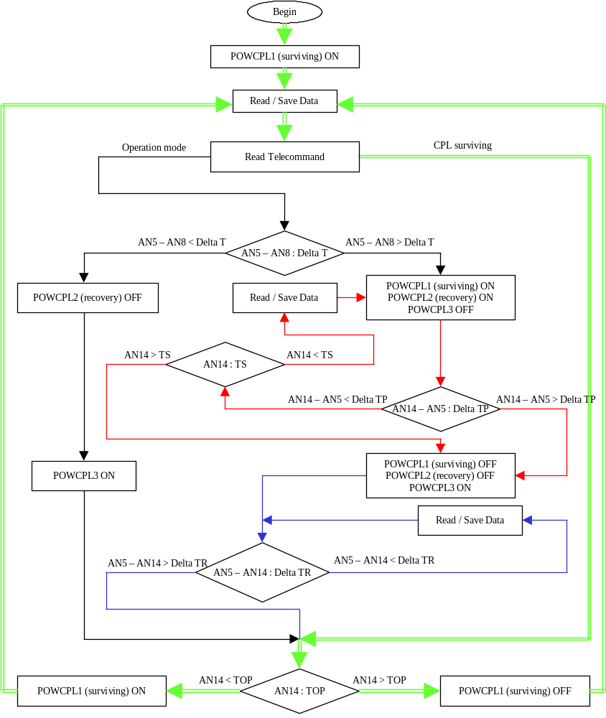

FBM |  |  | Document No. : | FBM-IC-UE-07-7142-INP
 |  |  | Page | 18
 |  |  | IDENT: | ICD-FBM-CP-07-740.000.00
INTERFACE CONTROL DOC. |  |  | EDITION N°: | 00 / Rev : 00
 |  |  | DATE: | 23/10/2003
SUBSYSTEM : | UFSC CPL/CBEMG/FLUXRAD |  | EQUIPMENT : | UFSC CPL/CBEMG/FLUXRAD
FORM TYPE : | ELECTRICAL BLOCK DIAGRAM
TOTAL NUMBER: |  | IN OPERATION: |  | IN REDUNDANCY:

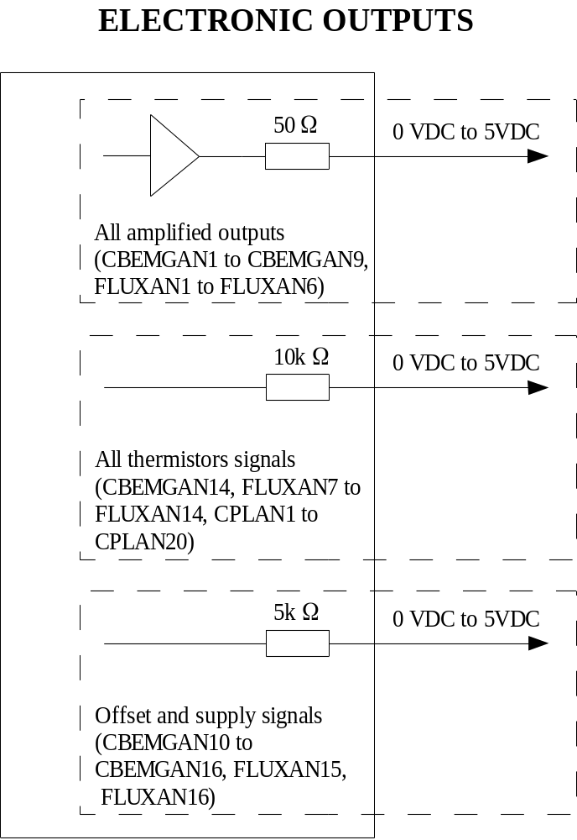

FBM |  |  | Document No. : | FBM-IC-UE-07-7142-INP
 |  |  | Page | 19
 |  |  | IDENT: | ICD-FBM-CP-07-740.000.00
INTERFACE CONTROL DOC. |  |  | EDITION N°: | 00 / Rev : 00
 |  |  | DATE: | 23/10/2003
SUBSYSTEM : | UFSC CPL/CBEMG/FLUXRAD |  | EQUIPMENT : | UFSC CPL/CBEMG/FLUXRAD
FORM TYPE : | ELECTRICAL BLOCK DIAGRAM
TOTAL NUMBER: |  | IN OPERATION: |  | IN REDUNDANCY:

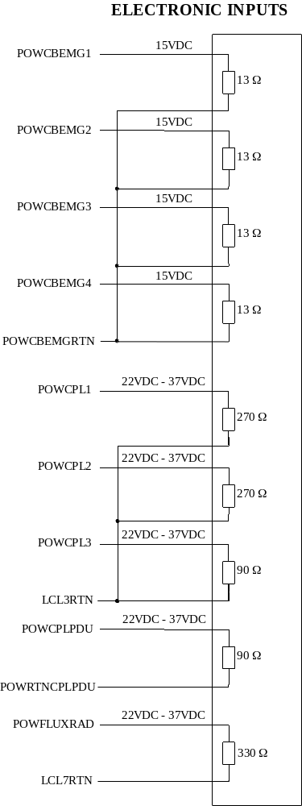

FBM |  |  | Document No. : | FBM-IC-UE-07-7142-INP
 |  |  | Page | 20
 |  |  | IDENT: | ICD-FBM-CP-07-740.000.00
INTERFACE CONTROL DOC. |  |  | EDITION N°: | 00 / Rev : 00
 |  |  | DATE: | 23/10/2003
SUBSYSTEM : | UFSC CPL/CBEMG/FLUXRAD |  | EQUIPMENT : | UFSC CPL/CBEMG/FLUXRAD
FORM TYPE :
TOTAL NUMBER: |  | IN OPERATION: |  | IN REDUNDANCY:

